
COMSATS University Islamabad

Sahiwal Campus, Pakistan

The Last Breath

By

Haseeb Nawaz CIIT/SP22-BCS-042

Muhammad Sharif CIIT/SP22-BCS-058

Supervisor
Mr. Hafiz Mudassir Khan

Bachelor of Science in Computer Science (2022-2026)

The candidate confirms that the work submitted is their own and appropriate credit has been given where reference has been made to the work of others

COMSATS University Islamabad
Sahiwal Campus Pakistan

Castle Destruction System

A project presented to
COMSATS Institute of Information Technology, Sahiwal Campus

In partial fulfillment
of the requirement for the degree of

Bachelor of Science in Computer Science (2022-2026)

By

Haseeb Nawaz CIIT/SP22-BCS-042/SWL
Muhammad Aazib Sharif CIIT/SP22-BCS-058/SWL

DECLARATION
We hereby declare that this software, neither whole nor as a part has been copied out from any source. It is further declared that we have developed this software and accompanied report entirely on the basis of our personal efforts. If any part of this project is proved to be copied out from any source or found to be reproduction of some other. We will stand by the consequences. No Portion of the work presented has been submitted of any application for any other degree or qualification of this or any other university or institute of learning.

Member Sign Member Sign

CERTIFICATE OF APPROVAL
It is to certify that the final year project of BS (CS) “The Last Breath” was developed by Haseeb Nawaz (CIIT/SP22-BCS-042/SWL) and Muhammad Aazib Shareef (CIIT/SP22-BCS-058/SWL), under the supervision of “Tahir Khalil” and co-supervisor “Hafiz Mudassir Khan” and that in their opinion; it is fully adequate, in scope and quality for the degree of Bachelors of Science in Computer Science.

Supervisor
Hafiz Mudassir Khan
Lecturer
Department of Computer Science
CUI Sahiwal

Head of Department
Dr. Zafar Roy
Department of Computer Science

Executive Summary

In this era, games and applications are used by multiple users for entertainment. Games developers first play the games to explore new ideas and then they use the functionality in their own games with their unique ideas introduced in them.
We will be creating a castle destruction game. It is an object/building/any solid material destruction game to be more precise. There will be a cannon/catapult (some sort of weapon) which will be able shoot stones/projectiles to hit the objects in order to destroy them and pass the level. Some further objects can also be included in the next levels if needed to make it more interesting. With the passage of time and further development our game will improve and reach its completion. We will be trying our best to make it as simple as we can for the person playing it, so they can simply enjoy its essence and themselves.
We will be creating a castle destruction game. It will have two to three levels, and in each level, we will introduce a variety of obstacles and ideas to make it more interesting for the player. At first, there will be just one or two castles in the game scene and in those castles, there will be some sort of pickup bonus, which will lead to completion of level. But the thing to keep in mind is that the player can’t pick up that bonus unless they destroy a significant portion of castle, and the bonus point is visible to them.

Acknowledgement

All praise is to Almighty Allah who bestowed upon us a minute portion of His boundless knowledge by virtue of which we were able to accomplish this challenging task.
We are greatly indebted to our project supervisor “Tahir Khalil” and our co- supervisor “Hafiz Mudassir Khan”. Without their personal supervision, advice and valuable guidance, completion of this project would have been doubtful. We are deeply indebted to them for their encouragement and continual help during this work.
And we are also thankful to our parents and family who have been a constant source of encouragement for us and brought us the values of honesty & hard work.

Member Sign Member Sign

Abbreviations

HCI |  | Human Computer Interaction
GUI |  | Graphical User Interface
UCD |  | Use Case Diagram
API |  | Application Programming Interface
DFD |  | Data Flow Diagram
FR |  | Functional Requirement
SD |  | Sequence Diagram
SRS |  | System Requirement Specification
SDD |  | Software Design Development
NFR |  | Non-Functional Requirement
App |  | Application
UML |  | Unified Modeling Language
FYP |  | Final Year Project
GD | Game Development

Table of content
Chapter 1 1
1 Introduction 2
1.1 Brief 2
1.1.1 Introduction of Project Work 2
1.1.2 Outcome of Work 2
1.1.3 Tools 3
1.2 Relevance to Course Modules 3
1.2.1 Programming Fundamentals (CSC103) 3
1.2.2 Game Development (CSC495) 3
1.2.3 Software Engineering (CSC291 & CSC392) 4
1.2.4 Software Requirements Engineering (CSE305) 4
1.2.5 Software Project Management (CSE494) 4
1.2.6 Human-Computer Interaction (CSC356) 4
1.3 Project Background 4
1.4 Methodology and Software Lifecycle for This Project 5
Chapter 2 7
2 Problem Definition 8
2.1 Problem Statement 8
2.2 Deliverables and Development Requirements 8
2.2.1 Functional Requirement 8
2.2.2 Deliverables: 9
Chapter 3 10
3 Requirement Analysis 11
3.1 Use Case Diagram 11
3.2 Functional Requirements 14
3.3 Non-Functional Requirements 15

Chapter 4 17
4 Design and Architecture 18
4.1 System Architecture 18
4.2 Process Flow/Representation 20
4.3 Design Models 21
4.3.1 Sequence Diagram 21
4.3.2 Class Diagram 22
Chapter 5 23
5 Implementation 24
5.1 Algorithm 24
5.2 External API 24
5.3 User Interface 24
5.3.1 Main Menu Screen 24
5.3.2 Level Selection UI 25
5.3.3 Level Pause 25
5.3.4 Game Completed 27
Chapter 6 28
6 Testing and Evaluation 29
6.1 Manual Testing 29
6.1.1 System testing 29
6.1.2 Unit Testing 29
6.1.3 Functional Testing 31
Chapter 7 32
7 Conclusion and Future Work 33
7.1 Conclusion 33
7.2 Future Work 33
Chapter 8 34
8 References 35

List of Figures
Chapter no . 3:
Figure 3.1: Main Menu Use Case
Figure 3.2: Settings Menu Use Case 11
Chapter no.4
Figure 4.1: Architectural Design of Game 18
Figure 4.2: Architectural Design 19
Figure 4.3: User Data Flow Diagram 19
Figure 4.4: Flow Chart 20
Figure 4.5: Sequence Diagram 21
Figure 4.6: Class Diagram 22
Chapter no.5:
Figure 5.1: Main Menu UI 24
Figure 5.2: Level Selection UI 25
Figure 5.3: Level pause 25
Figure 5.4: Settings 26
Figure 5.5: About 26
Figure 5.6: Game Complete 27

List of Tables

Table 1: 1.1.3 Tools and Technologies for Proposed Project 3
Table 2: 3.1 Play Game Use Case Description 12
Table 3: 3.1 Level Selection Description 12
Table 4: 3.1Settings Description 12
Table 5: 3.1Quit Level Description 13
Table 6: 3.1Continue Playing Description 13
Table 7: 3.1Quit Game Description 13
Table 8: 3.2FR-1 Description 14
Table 9: 3.2FR-2 Description 14
Table 10: 3.2 FR-5 Description 14
Table 11: 3.2 FR-6 Description 15
Table 12: 6.1.2 Unit Testing 1: Player Movement with and without obstacles 29
Table 13: 6.1.3 Unit Testing 2: Player Actions (Jump) 30
Table 14: 6.1.2 Unit Testing 3: Player Actions (Shoot) 30
Table 15: 6.1.2 Unit Testing 4: Player Actions (Chaos Destruction) 30
Table 16: 6.1.3 Functional Testing : Player Module 31

Chapter 1
Introduction

- Introduction
We will be creating a castle destruction game. It will have three levels, and, in each level, we will introduce a variety of obstacles and ideas to make it more interesting for the player. At first, there will be just small and decent castle in the game scene with minimal environment and within the castles (of each level), there will be some sort of pickup bonus, which will lead to completion of level. But the thing to keep in mind is that the player can’t pick up that bonus unless they destroy a significant portion of castle, and the bonus point is visible to them. The whole level will be built in scene to make it more attractive and appealing for the user.

Brief
This project focuses on developing a castle destruction game featuring three progressively challenging levels. Each level introduces new obstacles and creative gameplay elements to keep the experience engaging. Players will encounter a castle in every level, designed with its own unique environment and structure. Inside each castle lies a pickup bonus required to complete the level. However, the bonus remains inaccessible until the player destroys a significant portion of the castle, revealing the reward. The levels are fully crafted within detailed scenes to ensure an appealing and immersive experience for the player.

Introduction of Project Work
We will be creating a castle destruction game. It will have two to three levels, and, in each level, we will introduce a variety of obstacles and ideas to make it more interesting for the player.
As a player, you'll step into the shoes of a fearless warrior on a quest for conquest. Your ultimate goal is to dismantle towering fortresses and bring them crashing down to the ground. But it won't be easy these castles are fortified with defenses like walls, towers etc.
You'll need to employ cunning tactics, precise aim, and careful timing to overcome these obstacles. The whole level will be built in scene to make it more attractive and appealing for the user.

Outcome of Work
What we expect from this game is that the cannon/catapult should be able to shoot properly and destroy objects/obstacles. When all the major objects/enemies are destroyed we should be able to pass the level. Should be able to pause and continue game. And restart level or restart whole game. In general, Castle Destruction offers a range of gameplay options to suit your style.

Tools
Table 1: Tools and Technologies for Proposed Project
Tools &  Technologies | Tools | Version | Rationale
 | MS Visio | 2013 | Gantt Chart, Use Case, Incremental Model Diagram, Flowchart, Activity Diagram.
 | MS Word | 2019 | Documentation
 | MS PowerPoint | 2019 | Presentation
 | Technology | Version | Rationale
 | Unreal Engine | 5.1.1 | In unreal engine is use to save game data locally
 | Blender | v3.2 | The truffle boxes is used for asset modeling UV wrapping and animation.
 | ZBrush | 2022.0.1 | ZBrush for character modelling and other 3d models used in game.
 | Substance-Pinter |  | Substance-Pinter will be used for model texturing.
 | Houdini |  | Houdini will be used for high level procedural pipelining of game assets.

Relevance to Course Modules
The tools and technologies selected for this project directly support the learning outcomes and practical skills emphasized in the course modules. MS Visio, MS Word, and MS PowerPoint align with modules focused on software engineering documentation, project planning, and professional communication, enabling the creation of diagrams, reports, and presentations required throughout the development cycle.
In the game development modules, Unreal Engine 5.1.1 serves as the primary platform for implementing gameplay mechanics, physics, and environment interaction, reinforcing concepts taught in real-time systems, game engine fundamentals, and level design. Blender and ZBrush relate closely to modules covering 3D modeling, digital sculpting, UV mapping, and animation, providing hands-on experience with asset creation pipelines. Substance Painter supports modules focused on texturing techniques and material design, allowing students to apply realistic textures to 3D models. Meanwhile, Houdini connects to advanced modules involving procedural modeling, VFX creation, and pipeline automation, giving insight into industry-standard workflows for complex asset generation. Overall, these tools strengthen the practical application of theoretical concepts taught across the course, ensuring that students develop both technical proficiency and professional-level production skills.

Programming Fundamentals (CSC103)
We have studied the basics of programming in this course. Using the concepts of C++, we implemented this project.

Game Development (CSC495)
This course helped us to create games using technical knowledge and 3D game designing which are used in our project.

Software Engineering (CSC291 & CSC392)
This course helped us to evaluate our development methodologies, which are used in our project.

Software Requirements Engineering (CSE305)
In this course, we studied the basics of gathering functional and non-functional requirements. We gather requirements using different techniques.

Software Project Management (CSE494)
The software project management will help you to understand the complexities of organizational change and develop your ability to manage and deliver change successfully through projects, particularly via effective engagement of stakeholders. This course helps us to deliver the project on time with successful meetings with stakeholders.

Human-Computer Interaction (CSC356)
This course provides an introduction to and overview of the field of human-computer interaction (HCI) to give students an understanding of how the study of human-computer interaction affects the design of interactive systems and improves students’ awareness of the issues that determine the usability of an interactive computer system. This course helps us in developing an attractive user interface with a good color scheme.

Project Background
The game is set in a time of intense conflict, where rival factions compete for dominance and control over valuable resources. As a player, you take on the role of a skilled commander leading an army of warriors, siege engines, and magical entities. Your ultimate objective is to destroy enemy castles while protecting your own stronghold from opposing attacks. The game combines elements of strategy, resource management, and tactical combat.
The land is dotted with various types of castles, each possessing unique architectural designs, defensive structures, and strengths. These castles serve as the bastions of power for rival factions, housing their armies, treasuries, and strategic resources. Your task is to analyze the strengths and weaknesses of these fortresses and devise the most effective strategies to bring them down.
To achieve victory, you must gather resources, such as wood, stone, and gold, which are essential for constructing and upgrading your own castle's defenses and training your troops.
As you progress through the game, you'll encounter increasingly challenging opponents, each with their own unique strategies and castle designs. You must adapt your tactics, unlock new technologies, and upgrade your forces to stay ahead in the arms race. Conquer enemy territories, claim valuable resources, and expand your influence across the realm.
.

Methodology and Software Lifecycle for This Project
Our software will be deployed in cycles so we would be using spiral model for designing our software system. This model is deployed after every interaction/cycle and is used to deal with larger systems.
The Spiral Model for Castle Destruction Game Development Project:
Planning Phase:
Define the project objectives and goals, including the scope and vision of the castle destruction game. Conduct a feasibility study to evaluate technical, economic, and operational aspects of the project. Identify key stakeholders, including game designers, developers, artists, and testers. Establish a project timeline, milestones, and deliverables. Create a detailed project plan, including resource allocation and risk assessment.
Requirements Gathering:
Engage with the game designers to understand the desired gameplay mechanics, castle designs, and destruction objectives. Define the technical requirements, such as physics-based destruction mechanics, realistic visual effects, and interactive environments. Collaborate with artists to gather requirements for castle designs, textures, and visual assets. Conduct regular meetings and brainstorming sessions with the development team members to refine the requirements and align them with the project vision.
Design Phase:
The Design Phase transforms the game’s initial ideas and requirements into a complete blueprint that guides development by defining the system architecture, gameplay mechanics, level structure, and user interface. In this phase, the core modules such as the game engine structure, level manager, UI manager, physics system, and progression system are outlined to ensure smooth interaction and maintainability. Detailed gameplay mechanics are planned, including destruction physics, level completion rules, player input handling, and game state transitions. Level design focuses on castle layouts, obstacles, bonus placements, and environmental elements with increasing difficulty across levels. The user interface is carefully designed, covering the main menu, level selection, settings, pause menu, and completion screens, supported by UX planning to create intuitive navigation, consistent feedback, and smooth player flow. Visual and audio assets are defined through a unified style guide that covers medieval-themed textures, models, animations, sound effects, and background music. A Technical Design Document (TDD) specifies implementation details such as scripts, object structures, event handling, and optimization strategies. The phase also includes risk analysis to identify issues like performance constraints or UI scalability and proposes mitigation steps. Finally, the overall design is reviewed and validated to ensure alignment with project goals, gameplay objectives, and technical feasibility before moving into implementation.
Implementation Phase:
Begin the implementation of the castle destruction game based on the design specifications. Develop the core gameplay mechanics, including castle destruction algorithms, physics simulation integration, and player interactions. Implement the user interface elements, including menus, HUD, and control mechanics Create the 3D models, textures, and animations for the castles, tools, and visual effects, and integrate them into the game engine. Conduct regular code reviews (in our case, Blueprints) and testing to ensure quality and functionality.

Testing and Evaluation:
Perform unit testing, integration testing, and system testing to identify and resolve bugs, glitches, and performance issues. Conduct gameplay testing to evaluate the castle destruction mechanics, user experience, and overall gameplay balance. Gather feedback from testers and stakeholders to make iterative improvements to the game. Conduct usability testing to assess the user interface and control mechanics. Continuously evaluate and refine the game based on user feedback and testing results.
Deployment and Maintenance:
Regularly maintain and optimize the game, addressing any technical issues and ensuring compatibility with platform updates.
Iterative Development:
Throughout the development process, follow an iterative approach to refine and enhance the game based on feedback and evolving requirements. Continuously engage with stakeholders to gather feedback and make necessary adjustments. Plan and execute multiple development cycles to address new features, improvements, and bug fixes.
By following the Spiral Model, the castle destruction game development project can adapt to changing requirements, mitigate risks, and ensure high-quality gameplay experience while incorporating feedback from stakeholders and players.

Chapter 2
Problem Statement

Problem Definition
The problem is to design and develop a castle destruction game, where the player's objective is to demolish a castle using various strategies. The game should provide an immersive and engaging experience, allowing players to strategically plan and execute their attacks to bring down the castle while considering factors such as physics, structural integrity, and game mechanics.

2.1 Problem Statement
Design and develop a castle destruction type game that offers an engaging and entertaining experience for players. The game should provide an immersive environment where players can strategically plan and execute attacks on various castles, demolishing their structures and defenses using their weapon.
The key challenges to address in this game include:
- Gameplay Mechanics: Create intuitive and responsive controls that allow players to aim, control and deploy destructive weapons with precision, ensuring a satisfying and enjoyable experience.
- Castle Variety: Design a wide range of unique and visually appealing castles with varying layouts, architectures, and defensive structures. Each castle should present a distinct challenge for the players and encourage strategic thinking to overcome its defenses.
- Destructible Environments: Implement realistic physics and destruction systems to enable players to witness the realistic crumbling and destruction of castle structures. The destruction should be visually impressive and provide a sense of accomplishment for the players.
- Progression and Challenges: Maintain a balance between difficulty and player skill to keep the game engaging and challenging without becoming frustrating.

2.2 Deliverables and Development Requirements

2.2.1 Functional Requirement
Functional requirements for a castle destruction game could include the following:
- The game should allow players to destroy various elements of the castle, such as walls, towers, and roofs.
- The game should offer a variety of levels or scenarios with different castle layouts and challenges etc. This provides a sense of progression and keeps the gameplay engaging and diverse.
- The game should have an intuitive and user-friendly interface, allowing players to easily aim, launch attacks, selection of levels and other game options.
- The game should have immersive audio effects, such as projectile shoot and background music, to enhance the player's experience.
- The game should have basic player movement, so that the player can move around freely.
- The game should have Chaos based destruction to achieve better visuals when we destroy something.
These functional requirements provide a foundation for creating an engaging and enjoyable castle destruction game experience.

2.2.2 Deliverables:
- A clear and concise description of the game's concept, including its genre, target audience, and unique selling points.
- A comprehensive document outlining the game's mechanics, features, objectives, levels, characters, art style, and audio. It serves as a reference for the development team and stakeholders.
- The game requires various art assets, including 3D models for the castle, environment elements, characters, projectiles, and visual effects. It also includes 2D textures for UI elements, icons, and other graphical assets.
- Players should be able to destroy the castle using their weapon, with realistic physics interactions and visually satisfying destruction effects.
- A well-designed user interface that allows players to navigate menus, select levels, pause the game, exit the game, game end menu, and access different options from the menu list.

Chapter 3
Requirement Analysis

Requirement Analysis
Requirements analysis or requirements engineering is a process used to determine the needs and expectations of a new product. It involves frequent communication with the stakeholders and end-users of the product to define expectations, resolve conflicts, and document all the key requirements. There are two types of requirements functional requirement and non-functional requirement. The requirements of our project are discussed in the next topics.

Use Case Diagram
The Use Case Diagram represents the main interaction points available to the player when accessing the game’s Main Menu. It outlines the primary options the user can select, showing how they navigate into different parts of the game.
From the Main Menu, the player is presented with five key use cases:
- Play – This option allows the player to start the game. Selecting it typically leads to level selection or directly into gameplay.
- Settings – This use case lets the player customize various game preferences such as audio, controls, or graphics settings.
- Tutorial – By choosing the tutorial, the player can access introductory instructions or guidance on how to play the game, helping new users understand controls and mechanics.
- About – This option provides information about the game, such as credits, development details, or version information.
- Quit Game – This allows the player to exit the game from the main menu.
The diagram visually demonstrates how the player interacts with these use cases, showing that all of them branch directly from the Main Menu. This simple structure indicates that the main menu serves as the central hub for accessing the game’s core features

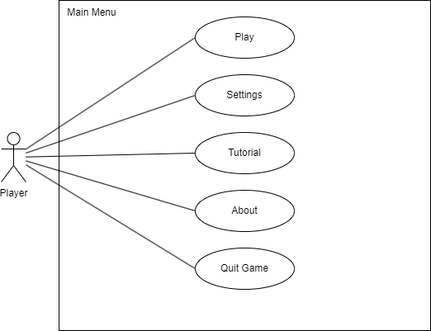
Figure 3.1: Main Menu Use Case

Use-Case Diagram Description: Settings Main Menu

Actor
- User
The person interacting with the application or system. The User accesses and modifies system settings to personalize their experience.

System
- Settings Main Menu
The central interface that allows the user to navigate and adjust different configuration options.

Use Cases

1. Access Settings Main Menu
- Description:
The User opens the Settings Main Menu from the application or device interface.
- Goal:
To view all available customizable settings categories such as Audio and Control.

2. Manage Audio Settings
- Description:
The User selects the Audio Settings option within the Settings Main Menu.
- Includes:
  - Adjust volume levels
  - Change sound effects settings
  - Enable/disable background music
  - Configure audio output device (optional)
Goal:
To tailor the audio experience according to user preference

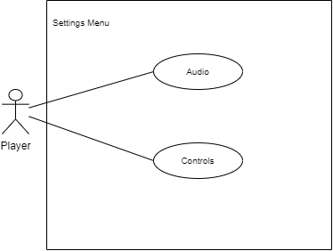
Figure 3.2: Settings Menu Use Case

Use-Case Diagram Description: Settings Main Menu

Actor
- User
The person interacting with the application or system. The User accesses and modifies system settings to personalize their experience.

System
- Settings Main Menu
The central interface that allows the user to navigate and adjust different configuration options.

Use Cases

1. Access Settings Main Menu
- Description:
The User opens the Settings Main Menu from the application or device interface.
- Goal:
To view all available customizable settings categories such as Audio and Control.

2. Manage Audio Settings
- Description:
The User selects the Audio Settings option within the Settings Main Menu.
- Includes:
  - Adjust volume levels
  - Change sound effects settings
  - Enable/disable background music
  - Configure audio output device (optional)
- Goal:
To tailor the audio experience according to user preference.

3. Manage Control Settings
- Description:
The User selects the Control Settings option within the Settings Main Menu.
- Includes:
  - Remap or configure input controls
  - Adjust sensitivity (e.g., mouse, joystick, controller)
  - Toggle control assist or accessibility options
- Goal:
To customize how the user interacts with the application or device.

Relationships
- User → Access Settings Main Menu
The User initiates interaction with the settings interface.
- Access Settings Main Menu → Manage Audio Settings (extends)
Audio Settings become available once the main menu is accessed.
- Access Settings Main Menu → Manage Control Settings (extends)
Control Settings become available once the main menu is accessed.

Use Case Description
Some detailed use cases are given below in tabular form:
The Play Game Use Case outlines the steps and system behavior when a player chooses to start gameplay from the main menu. This use case focuses on the interaction triggered by the Play button and the subsequent actions taken by the system to guide the player toward selecting a game level. The use case, identified as UC-1, involves the primary actor the Player. When the player selects the Play option on the main menu, the system responds by opening a dedicated sub-menu where all available levels are displayed. This allows the player to choose which level they want to begin or continue playing. There are no preconditions, meaning the player can always access this option upon entering the main menu. The postconditions ensure the system transitions correctly by presenting the full list of levels in an organized and accessible layout. The normal flow begins with the player launching the game, followed by selecting the Play button, which triggers the level selection interface. Overall, this use case defines a straightforward and essential part of the game’s navigation, guiding the player from the main menu into the level selection process.

Use Case ID: | UC-1
Use Case Name: | Play
Actors: | Player
Description: | Play button lets you open a sub-menu to select a level to play
Trigger: | Play button
Preconditions: | None
Postconditions: | - Sub-menu is opened  - All levels are shown on the screen as part of that sub-menu
Normal Flow: | - Player launches the game  - Player clicks on Play button
Table 2: Play Game Use Case Description
The Level Selection Use Case defines how the player navigates from the main menu into a specific level of the game. This use case activates once the player has already clicked the Play button and is ready to choose which level to begin. In this interaction, the primary actor is the Player, who initiates the process by selecting the Level Selection button. When triggered, the system opens the level selection menu, displaying all available levels. After the player chooses a level, the system loads and starts the selected gameplay scene. The precondition requires that the player must have already pressed the Play button from the main menu. The postconditions ensure proper system behavior by confirming that the level selection interface appears and that the chosen level successfully begins. The normal flow describes the standard expected behavior: the player launches the game, selects Play, and then clicks the level selection button to choose a level. The alternative flow outlines other possible scenarios. If a player exits a level, the system returns them to the level selection screen. Upon completing a level, players may choose to continue to the next one. If they fail or lose a level, they can retry it or pick a different level from the selection menu. Overall, this use case provides a clear structure for how players navigate between gameplay states, ensuring smooth transitions from the main menu to level selection and into active gameplay.

Use Case ID: | UC-2
Use Case Name: | Level Selection
Actors | Player
Description: | To start the game and select a level
Trigger: | Level select button
Preconditions: | Player has clicked on the Play button
Postconditions: | - Level selection menu is opened  - Selected level has started
Normal Flow: | - Player launches the game  - Player clicks on Play button  - Player clicks on level selection button
Alternative Flow: | - Level exit and goes to level selection  - Level completed, player select next level  - Level lost, player retry or select new level
Table 3: Level Selection Description

Use Case ID: | UC-3
Use Case Name: | Settings
Actors: | Player
Description: | To open the settings menu and change various parameters and adjust according to a player’s needs
Trigger: | Settings button
Preconditions: | None
Postconditions: | Settings menu opens up
Normal Flow: | - Player launches the game  - Player clicks on Settings button
Alternate Flow: | None
The Settings Use Case describes how a player accesses and interacts with the settings menu

to customize their gameplay experience. This use case is initiated when the player selects the Settings button from any accessible menu within the game. The primary actor for this interaction is the Player, who may choose to adjust various parameters such as audio levels, graphics options, control settings, or gameplay preferences. This ensures the game environment is tailored to the player’s comfort and device capabilities. There are no preconditions, meaning the settings menu can be accessed at any time the Settings button is available. The postcondition guarantees that the system successfully opens the settings interface, allowing the player to view and modify configuration options. The normal flow involves the player launching the game and clicking on the Settings button, which immediately brings up the settings menu. Since the action is straightforward and does not branch into additional scenarios, there are no alternate flows associated with this use case. Overall, UC-3 defines a simple yet essential feature that enhances user experience by providing players with the ability to personalize their game settings efficiently and intuitively.
Table 4: Settings Description

The Quit Level Use Case explains how a player exits an active level and returns to a different part of the game, such as the level selection menu or main menu. This use case is initiated when the player selects the Quit button during gameplay. The primary actor is the Player, who may choose to quit a level for various reasons, such as wanting to change levels, adjust settings, or stop playing. The precondition for this use case is that the player must currently be engaged in an active level. Once the Quit button is pressed, the system displays a warning message to prevent accidental exits. This message typically asks the player to confirm the action, ensuring they do not unintentionally lose progress. This confirmation step forms the postcondition of the use case. The alternate flow describes scenarios where the quit option is selected after a level has ended. If the level is already completed and the player is on the Level Complete Menu, selecting Quit takes them out of the level without needing a warning prompt. This ensures smoother navigation once the objective has already been achieved. Overall, UC-4 outlines a safe and user-friendly process for exiting a level, helping maintain player control while minimizing unintended disruptions in gameplay.
Table 5: Quit Level Description
Use Case ID: | UC-4
Use Case Name: | Quit Level
Actors: | Player
Description: | Quit and leave a level
Trigger: | Quit button
Preconditions: | A level is being played
Postconditions: | - Warning message is displayed
Alternate Flow: | Level completes  Player clicks on Quit from the Level Complete Menu

Use Case ID: | UC-5
Use Case Name: | Continue
Actors: | Players
Description: | Proceed to next level after level completion
Trigger: | Continue button
Preconditions: | - A level is being played  - Pause menu is opened
Postconditions: | Game is continued
Normal Flow: | - Player launches the game  - Player clicks on Play  - Player clicks on any level’s button  - Player hit TAB from keyboard  - Pause menu opens up  - Player clicks on Continue Button  - Game is resumed
Table 6: Continue Playing Description

level after completing or pausing a current level. This interaction is initiated when the player selects the Continue button from the Pause Menu or Level Complete interface. The primary actor is the Player, who uses the Continue option to move forward without interruption. The preconditions require that a level is currently active and that the Pause Menu is open indicating that the game has been temporarily halted. Once the Continue button is selected, the system resumes gameplay, marking the postcondition that the game continues from the point it was paused or smoothly advances to the next stage.
The normal flow outlines the typical sequence of events:
- The player launches the game.
- The player selects the Play option.
- The player chooses a level to begin.
- During gameplay, the player presses the TAB key to activate the pause function.
- The Pause Menu opens.
- The player clicks the Continue button.
- The game resumes from the paused state.
This use case ensures that players can easily pause and resume their gameplay without losing progress, supporting a seamless and user-friendly experience. It also helps maintain game flow by enabling quick continuation after short interruptions

Use Case ID: | UC-7
Use Case Name: | Quit Game
Actors: | Player
Description: | To quit the game as a whole
Trigger: | Quit Game button
Preconditions: | None
Postconditions: | Game is closed
Normal Flow: | - Player launches the game  - Player clicks on Quit Game button
Alternate Flow: | - Player is currently completing a level  - Player presses the TAB key from the keyboard  - Player clicks on Exit
Table 7: Quit Game Description

The Quit Game Use Case describes the process by which a player exits the game application entirely. This action is intentionally designed to be simple and accessible, allowing players to close the game from any major interface. The primary actor is the Player, who triggers this interaction by clicking the Quit Game button. Because quitting the game is a global action, there are no preconditions the player can choose to exit at any point. Once the quit command is issued, the system responds by closing the game application, which serves as the postcondition. The normal flow begins when the player launches the game and then selects the Quit Game button from the main menu, resulting in the immediate closure of the game.
The alternate flow describes a scenario where the player is still within an active level. In this case, the player may pause the game by pressing the TAB key, which opens the Pause Menu. From this menu, the player can select the Exit option to quit the game directly without returning to the main menu. This ensures the player can exit quickly and conveniently even during active gameplay. Overall, UC-7 ensures that players have clear, consistent, and accessible methods for closing the game, whether they are navigating menus or playing a level.

3.2 Functional Requirements
Functional Requirements are defined as the requirements, which are essential for the system.
Identifier | FR-1
Title | Player: Movement
Requirement | Player should be able to walk and move and perform actions
Source | Related System Analysis
Rationale | To allow the players to move and explore environment and interact with it
Business Rule | N/A
Dependencies | N/A
Priority | High
Table 8: FR-1 Description

Table 9: FR-2 Description
Identifier | FR-2
Title | Player: Attack
Requirement | The player shall be able to attack enemies such as raid bosses, monsters, creeps etc.
Source | Related System Analysis
Rationale | The player being able to attack is the most important functions, it will allow them to defeat enemies or clear obstacles.
Business Rule (if required) | N/A
Dependencies | N/A
Priority | High

Identifier | FR-5
Title | Chaos Destruction (Unreal Engine Module)
Requirement | Plyer should be able to damage objects and destroy them with projectiles
Source | Related System Analysis
Rationale | Game functionality
Business Rule | Castle will go into destruction mode if hit by player projectile
Dependencies | This depends on player and even on itself as well.
Priority | High
Table 10: FR-5 Description

Identifier | FR-6
Title | UI: Settings
Requirement | The player shall be able to manage settings
Source | Related System Analysis
Rationale | Ease of play
Business Rule | N/A
Dependencies | N/A
Priority | Medium
Table 11: FR-6 Description

3.3 Non-Functional Requirements
Non-Functional Requirements are the requirements that specify criteria that can be used to judge the operation of the system. Those constraints under which the system will be operated are called non-functional requirements.
3.3.1 Reliability
- The game will work without any errors or crashes 98% of the time.
- The game should not crash on Fullscreen mode like most games do.
- Proper level functionality will work.
- The sound settings will enable us to turn off or on sound.
3.3.2 Usability
- The player should be able to quit at any time while playing.
- Player can pause game at any time in level.
- Game should resume from where the player paused it.
3.3.3 Performance
- The game will be able to run at a minimum of 30 frames per second on 80% of desktop systems.
- The game will on average take 15 seconds to load into the game.
- The game will be playable even on average systems.
3.3.4 Quality
- Environments and levels should be free of any bugs or glitches.
- The game environment should be in stylized style, to make it more appealing and nicer look.
- Graphics should be kept as high as possible by using High-Definition Render Pipeline of Unreal Engine.
- Game assets will have low-poly mesh base which will allow better animation

Chapter 4

Design and Architecture

Design and Architecture
The architecture of a system describes its major components, their relationships (structures), and how they interact with each other.

4.1 System Architecture
We will be using monolithic architecture for the project and use the spiral model for software development (in our case for game development). The module mapping for each layer is as follows:
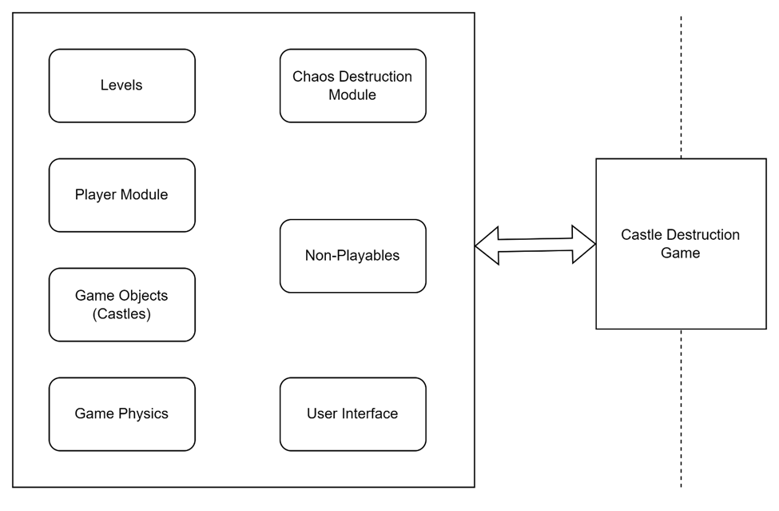
Figure 4.1: Architectural Design of Game

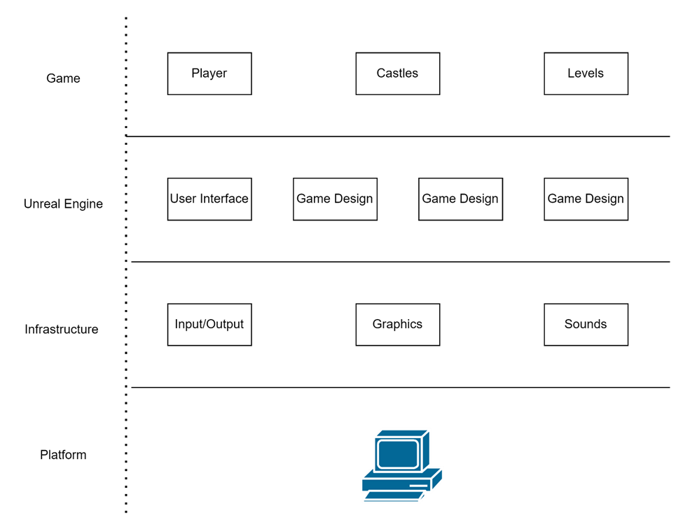
Figure 4.2: Architectural Design
Data Flow Diagram
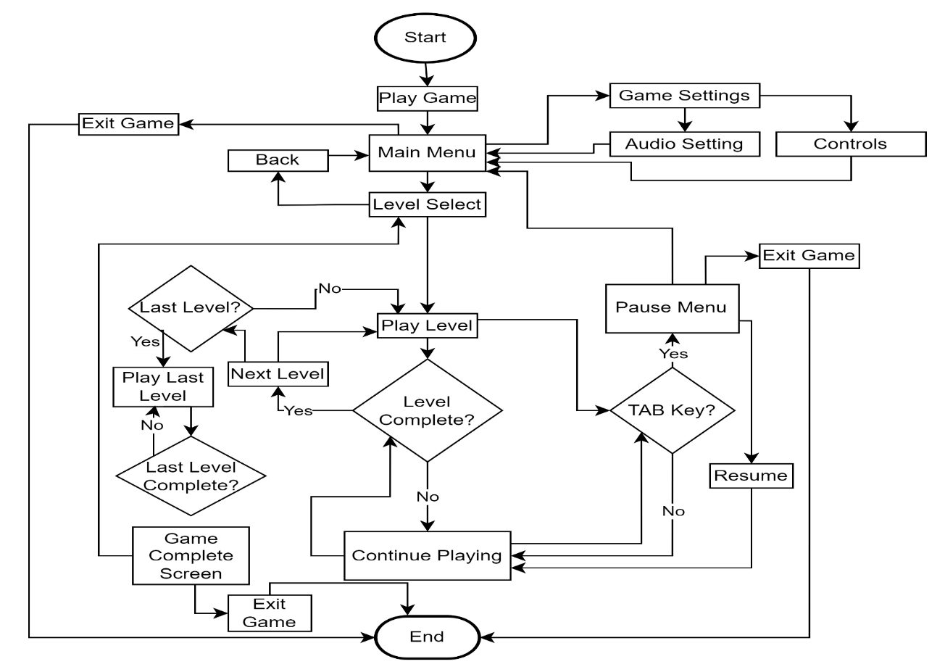

Figure 5: User Data Flow Diagram

4.2 Process Flow/Representation

The process flow illustrates the complete progression a player follows when interacting with the game from launch to level completion. The sequence begins at the Start point, which leads to the game opening and displaying the Main Menu. At this stage, the player can either choose to Exit Game, which immediately ends the process, or continue by selecting an option that moves them to the Level Select screen. After selecting a level, the game transitions into the Game Play phase, where the player actively engages with the level. When gameplay is in progress, the system continuously checks whether the level has been completed. If the answer is No, the player remains in gameplay until completion conditions are met. If the answer is Yes, the process moves to the Next Level stage. At this point, the system evaluates whether the next level is the Last Level. If it is not the last level, gameplay continues as the player enters the upcoming level. If it is the final level, the flow ends by presenting the Level Complete Widget, signifying full completion of the game’s progression. Overall, the diagram provides a clear representation of the user’s journey through game initialization, level selection, gameplay loops, and final completion conditions.

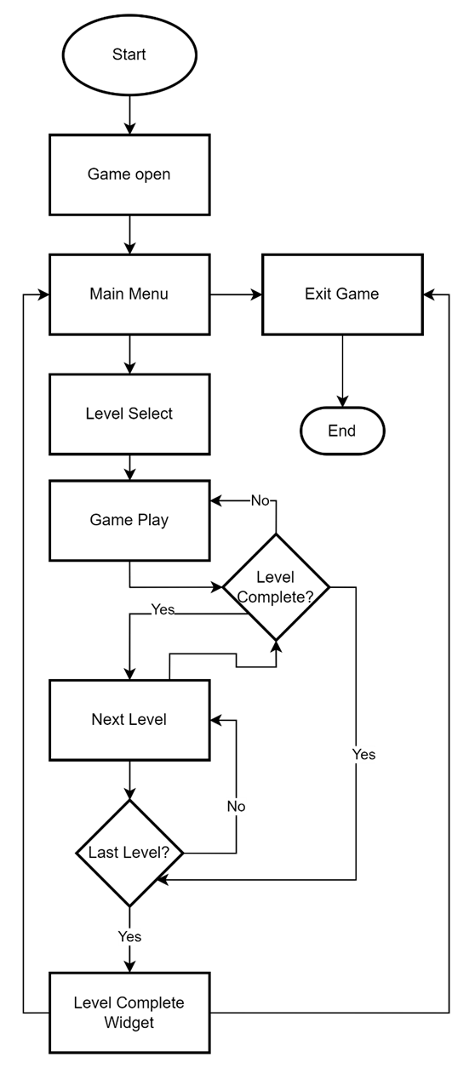
Figure 6: Flow Chart

4.3 Design Models
Design Models are structured representations of a system, process, or product that illustrate how its components interact and function to meet specified requirements. They serve as blueprints that guide development by capturing the architecture, behavior, and relationships of various elements in a visual or conceptual form. Design models can include diagrams, schematics, prototypes, or formal models that represent data structures, system workflows, user interfaces, and functional interactions. By providing a clear, detailed, and standardized depiction, design models help stakeholders understand the system’s intended operation, facilitate communication between teams, support validation and testing, and reduce the risk of errors during implementation.

4.3.1 Sequence Diagram
The sequence diagram illustrates the complete interaction flow between a player and the various game states in a level-based game. It begins at the Main Menu, where the player can start the game or exit entirely. Choosing to start transitions the user to the Level Selection screen, where a level can be chosen or the player may return to the Main Menu. After selecting a level, the player enters the Level Start screen, which serves as a preparation point before gameplay; from here, they may either begin the level or go back to the Main Menu. Once the level begins, the user reaches the Game Play state, where active gameplay occurs. During gameplay, the player can pause the game, which opens the Pause Menu. From the Pause Menu, they may either resume playing or exit back to the Main Menu. Completing a level lead to the Level Complete screen, where the player may proceed to the next level or, if the stage is the final one, continue to the Last Level. After the final gameplay section is finished, the user is taken to the Game Complete screen, marking the end of the game experience. Across these transitions, the diagram clearly demonstrates how user actions guide movement between menus, gameplay states, and completion screens, providing a full overview of the game’s navigation and progression structure

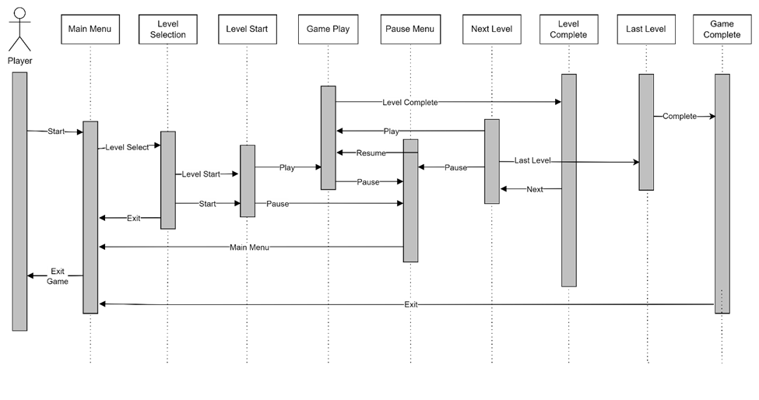
Figure 7: Sequence Diagram

Class Diagram

The class diagram represents the structural relationships between several core components of a game system, illustrating how gameplay, world interaction, player control, and visual effects are interconnected. At the center of the design is the Game class, which coordinates the overall flow and interacts with most other classes. It manages the current game state, level progression, and connections to gameplay elements such as the Player, World, and Castle Destruction systems. The Player class encapsulates player-related data and behaviors, including handling input, animations, and movement. It collaborates with the Input Handler to receive player commands and with Player Movement to calculate movement direction, speed, and physics updates. The Animation class is linked to the Player to control visual feedback such as running or idle states. The Weapon class represents the player's equipped weapon, storing data such as damage and attack speed, and interacting with the Player to perform attacks. The World class represents the game environment, containing level data, world settings, and objects that the player interacts with; it communicates with the Game class to load and manage levels. The Castle and Castle Destruction classes seem to represent special world elements or gameplay systems: Castle appears as a unique environment component connected to the Game, while Castle Destruction likely manages destruction physics or effects that impact the world state. Overall, the diagram shows a well-organized architecture where the Game class orchestrates higher-level flow, the Player handles interactive behavior, the World defines the environment, and supporting classes such as Input Handler, Animation, and Weapon provide specialized functionality that enriches gameplay.

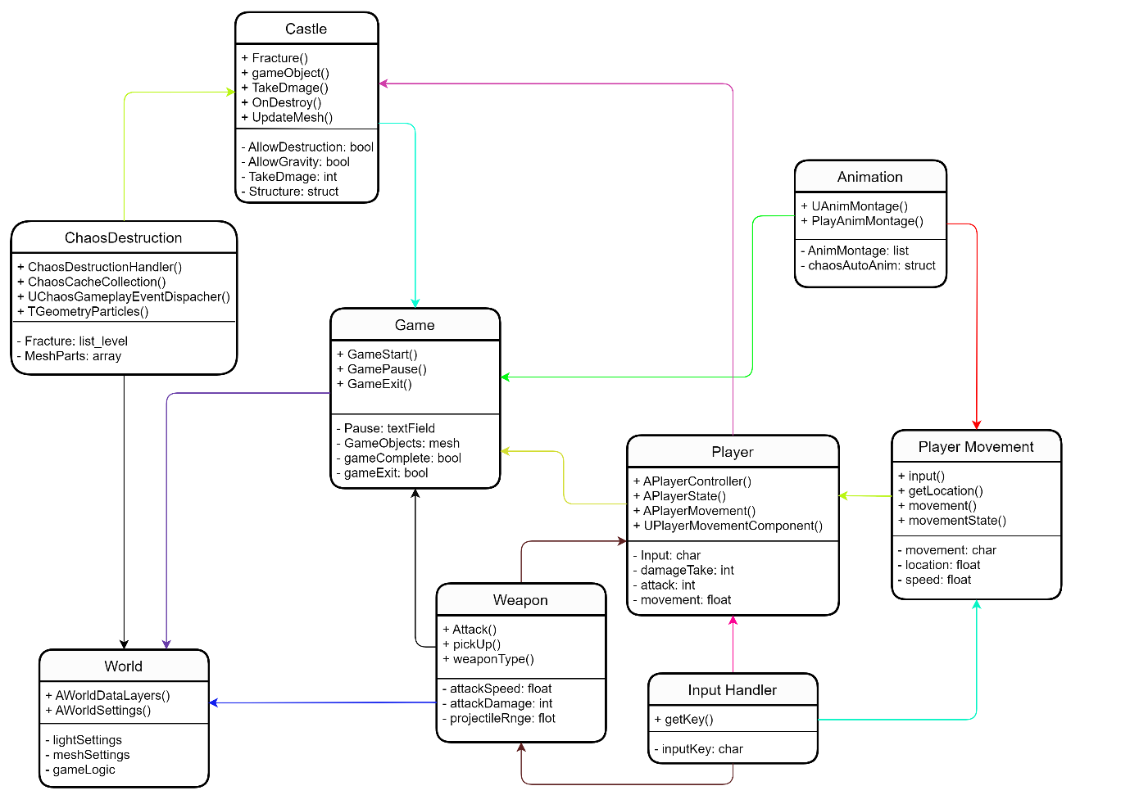

Figure 8:Class Diagram

Chapter 5

Implementation

Implementation
The project involves the development of a castle destruction game consisting of three progressively challenging levels. Each level is designed as a complete scene featuring a unique castle structure, environmental elements, and interactive gameplay components. The core mechanic centers on destruction-based progression. In every level, the player must strategically damage and destroy a significant portion of the castle in order to access a hidden bonus pickup. This bonus serves as the primary objective for completing the level. Although the bonus item is visible to the player from the start, it remains unreachable until enough of the castle has been demolished, encouraging players to engage with the destruction mechanics. To enhance player engagement, each level introduces new obstacles, layout variations, and environmental details, making the gameplay increasingly dynamic and visually appealing. The castles differ in size, complexity, and structural features, allowing for varied strategies and interactions. All elements within the scene castle components, props, terrain, and interactive objects are carefully arranged to create an immersive and polished gameplay experience. This implementation not only highlights the game's core idea of progressive destruction but also ensures a satisfying blend of visual appeal, challenge, and player-driven interaction across all three levels.

5.1 Algorithm
We’ll discuss our game’s main algorithm step-by-step and will look into how the game flow works through it.

- Step 1: Player opens the game
- Step 2: Player goes to level selection option
- Step 3: Player selects a level from level selection menu
- Step 4: Player continues to play the game
- Step 5: If level is completed the player spawns into the next level
- Step 6: Player pauses the game. It will lead us to pause menu which have three instances in it

5.2 External API
No, there is not any external API used in this project. All the functionalities are implemented internally, and the system operates independently without relying on third-party application programming interfaces. This ensures full control over the project’s components and eliminates external dependencies.

User Interface

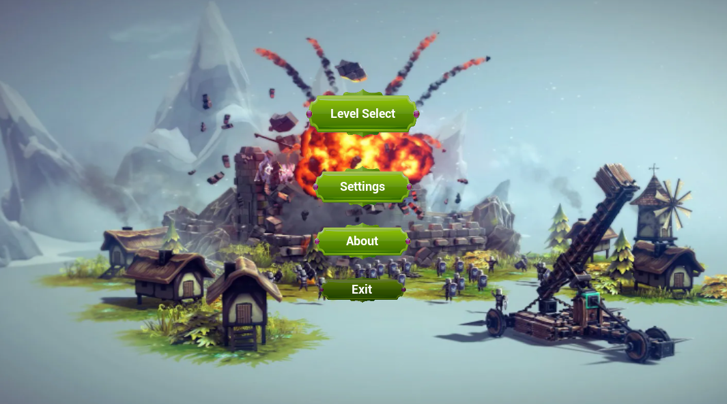
Figure 9: Main Menu UI
The user interface (UI) of the castle destruction game is designed to be simple, intuitive, and visually aligned with the medieval theme of the gameplay. The UI elements are positioned to ensure that players can focus on the destruction mechanics while still having access to essential information and controls.
1. Main HUD (In-Game Interface)
- Health/Power Indicator: Displays the player’s current strength, weapon power, or remaining attempts (depending on the game’s mechanics). Positioned in the top-left corner for quick visibility.
- Level Objective Display: A small text prompt in the top-center briefly reminds the player of the current objective e.g., “Destroy the Castle to Reach the Bonus!”.
- Bonus Indicator: A subtle icon or marker appears when the bonus pickup becomes accessible, guiding the player toward its location.
- Score/Progress Tracker: Shows the percentage or amount of the castle destroyed, helping players understand how close they are to unlocking the bonus.
- Pause/Menu Button: Located in the top-right corner, allowing quick access to settings, controls, or level restart options.
2. Pause Menu
- Resume Button to return to gameplay.
- Settings Panel to adjust audio, graphics, and controls.
- Restart Level option.
- Exit to Main Menu.
3. Main Menu Interface
- Play Button: Starts the game or opens the level selection screen.
- Level Selection: Displays available levels and those unlocked by completing previous ones.
- Settings: Access to audio, control bindings, display options, etc.
- Exit Game (for PC builds).
4. Level Completion Screen
- Shows the bonus collected, destruction percentage achieved, and a Continue button to proceed to the next level.
- Includes a Replay Level option for players who want to improve their performance.
5. Visual Style
The UI uses medieval-inspired fonts, stone-textured panels, and warm color accents to complement the castle theme. Icons are simple and bold to remain readable during active gameplay. The UI maintains a clean, unobtrusive layout to support the fast-paced destruction mechanics.

Main Menu Screen
The Main Menu Screen serves as the player's entry point into the game and establishes the overall tone with a visually appealing medieval theme. The background features a stylized castle landscape or a subtle animated scene that reflects the destruction-and-adventure concept of the game. The layout is clean, intuitive, and easy to navigate. At the center of the screen, large interactive buttons guide the player to core game options. The “Play” button is prominently displayed, encouraging players to start or continue their progress. Selecting “Play” leads to the level selection screen, where players can choose from the available levels.
Below or beside the main play button, additional options include:
- Level Selection – Allows players to pick any unlocked level and view progress.
- Settings – Provides access to audio controls, graphics settings, and input customization.
- Help/Instructions – Offers basic gameplay tips or controls for new players.
- Exit Game – Closes the application (for PC versions).
The menu uses medieval-style fonts and UI elements such as wooden or stone-textured buttons to complement the game’s theme. Soft ambient music or subtle sound effects enhance the atmosphere without overwhelming the player. Overall, the Main Menu Screen is designed to be visually immersive, easy to navigate, and thematically consistent with the castle destruction gameplay experience.

Level Selection UI
The Level Selection UI provides players with a clean and intuitive interface to choose from the available levels in the castle destruction game. Its design reflects the medieval theme, using textured panels, stone-framed buttons, and subtle atmospheric visuals to maintain consistency with the rest of the game. The screen is organized around a central layout that displays each level as a selectable card or icon. These level icons may include small preview images of the castle layout or environment to give players a visual hint of what to expect. Levels that are already unlocked appear in full color and are fully interactive, while locked levels are shown with dimmed visuals, lock icons, or grayed-out frames to indicate that they require completion of earlier levels to access.
Each level card displays:
- Level Number or Title (e.g., Level 1: Small Fortress)
- A preview image or thumbnail of the castle
- Completion Status, such as stars, checkmarks, or destruction percentage (optional)
At the bottom or side of the screen, navigation buttons allow the player to return to the Main Menu or access settings if needed. Hover or selection effects (such as glowing borders or subtle animations) help guide the player’s attention and improve usability.The overall design of the Level Selection UI focuses on clarity, ease of use, and thematic immersion. It enables players to quickly view their progress and jump directly into the level they want while maintaining the game's medieval aesthetic and atmosphere.

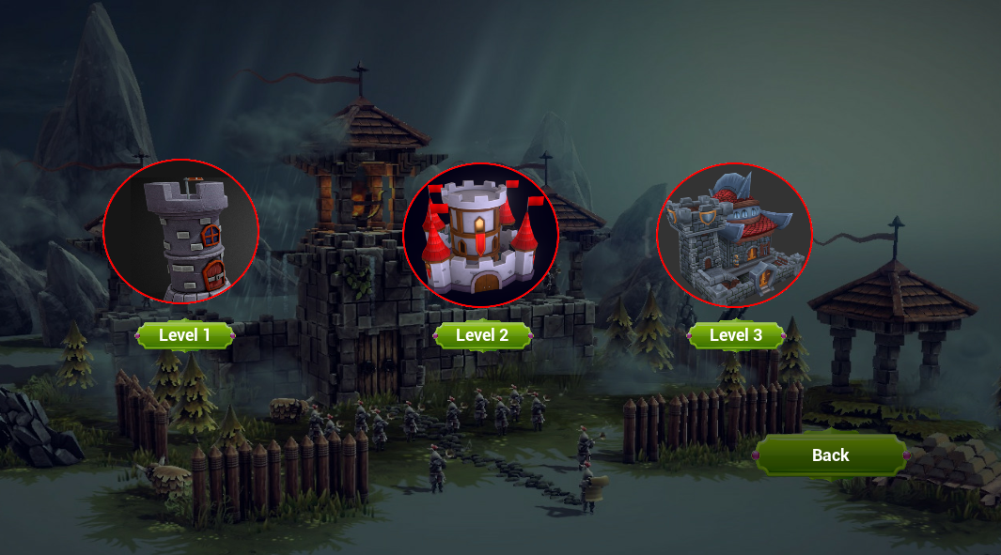

Figure 10: Level Selection UI

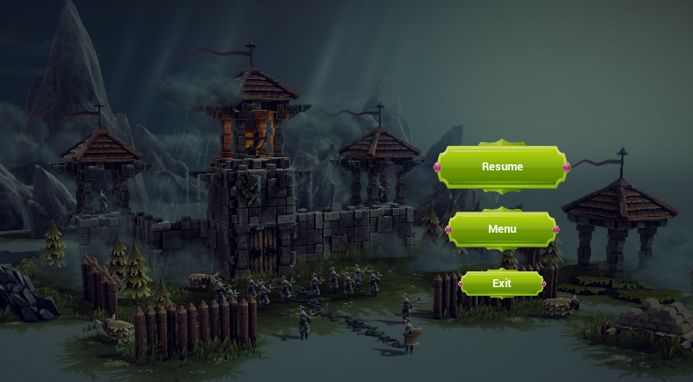
Level Pause UI
The Level Pause UI in the Laravel application provides players with a simple and intuitive interface to temporarily stop gameplay and access essential in-game controls. This UI is implemented using Laravel Blade templates and is displayed as an overlay that appears on top of the current game screen whenever the player activates the pause function. The pause interface features a full-screen semi-transparent overlay, dimming the background to indicate that gameplay is halted. At the center of the screen, a styled pause menu panel appears, containing all available actions. These include:
- Resume Button – Allows the player to return directly to the game by closing the pause overlay.
- Restart Level – Reloads the current level route, enabling the player to start over.
- Main Menu Button – Redirects the player back to the game’s main menu screen.
The design uses clear, high-contrast buttons to make all actions easily accessible and readable. Each button is styled consistently using custom CSS, maintaining a clean and user-friendly layout. The UI also follows Laravel’s layout structure, using Blade components and routes to ensure smooth navigation between pages. Overall, the Level Pause UI in Laravel enhances user experience by offering a seamless and visually consistent way for players to manage gameplay, restart levels, or navigate back to the main menu without disrupting immersion.

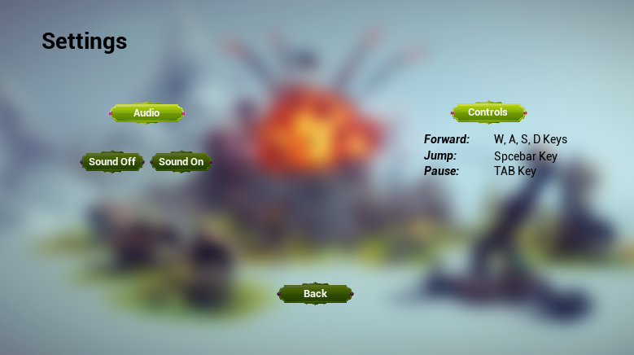
Settings UI

Figure 11: Level pause

The Settings UI provides players with a straightforward and accessible interface to customize their gameplay experience. Designed with clarity and usability in mind, the Settings Screen uses a clean layout and themed visual elements that remain consistent with the game’s medieval aesthetic. Textured panels, subtle icons, and warm, earthy tones help maintain immersion without distracting from functionality. The interface is divided into clearly labeled sections, allowing players to quickly locate and adjust important game preferences. Key categories typically include:
- Audio Settings:
Sliders for adjusting background music, sound effects, and overall volume. Players can mute specific audio channels for a personalized experience.
- Graphics Settings:
Options such as resolution, brightness, shadow quality, and overall performance presets (Low, Medium, High). These settings help players optimize the game according to their device’s capabilities.
- Control Settings:
Allows players to view or customize key bindings, controller layouts, or touch input settings depending on platform. This ensures comfort and accessibility for all play styles.
- Gameplay Preferences:
Optional toggles such as displaying hints, camera sensitivity, or enabling/disabling UI assist features. These support different player preferences and accessibility needs.
Navigation buttons at the bottom of the screen allow users to Save Changes, Reset to Default, or return to the Main Menu. Clear visual feedback, such as highlighting the selected option or showing confirmation prompts, ensures a smooth user experience. Overall, the Settings UI enhances player comfort and control by providing a well-organized menu where users can tailor their game environment, audio, and controls to suit their gameplay preferences.

About UI

About UI Description
The About UI provides players with a dedicated space to learn more about the game, its purpose, and the team or individuals behind its development. Designed with simplicity and clarity, the About Screen uses clean typography, themed decorative elements, and a well-structured layout that aligns with the overall medieval aesthetic of the game. At the top of the screen, a prominent title such as “About the Game” introduces the section. The main content area typically includes a brief overview of the game’s concept, goals, and the creative vision behind its development. This may describe the castle destruction theme, the core gameplay mechanics, and the inspiration behind the project. Below the game overview, the screen may present additional details such as:
- Developer Information:
Names of team members, roles, or contributors involved in designing, programming, art creation, or testing.
- Purpose and Background:
A short explanation of why the game was created—whether as an academic project, creative experiment, or entertainment product.
- Version Information:
The current game version, update notes, or build details (optional).
- Acknowledgments:
A section to thank mentors, instructors, supporting organizations, or any external resources used during development.
The layout maintains readability, often using scrollable content if necessary. A Back or Main Menu button is placed conveniently at the bottom or top corner, allowing users to return to navigation easily. Overall, the About UI enriches the user experience by offering context, transparency, and appreciation for the work involved in creating the game, making it a thoughtful and informative addition to the interface.

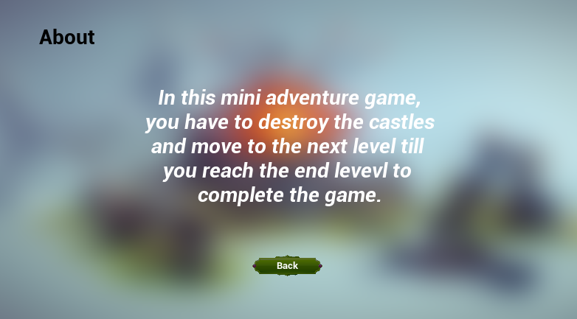
Figure 13: About

Game Completed UI
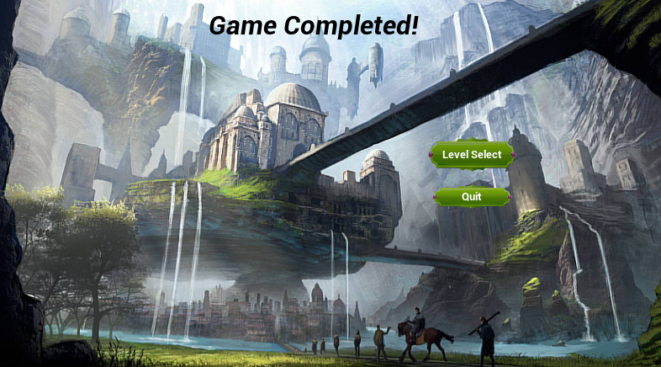
Figure 14: Game Complete

Chapter 6

Testing and Evaluation

Testing and Evaluation
The purpose of testing is to discover and detect errors. Testing is the process of trying to discover every conceivable fault or weakness in a work product. It provides a way to check the functionalities of components, sub-assemblies, or a finished product it is the process of exercising software with the intent of ensuring that the software system meets its requirements and user expectations and does not fail unacceptably. There are various types of tests. Each test type addresses a specific testing requirement. The system is tested many times while we were developing it. Many errors have been removed which we were facing at the time of development of this project. The testing and evaluation process identified several issues that were addressed before the system was deployed. These issues included bugs in the code (Blueprints), some references in blueprints, usability issues in the user interface, and performance issues related to the speed and efficiency of the system.

Manual Testing

6.1.1 System testing
System testing ensures that the entire integrated software system meets requirements. It tests a configuration to ensure known and predictable results. An example of system testing is the configuration-oriented system integration test. System testing is based on process descriptions and flows, emphasizing pre-driven process links and integration points. The complete system is tested many times to ensure the normal working of the system. The system is tested in which we have checked all aspects, which can create problems for the end-user, and in the end, the system is working fine. After doing System Testing on the whole game. To date, our overall game is working perfectly fine with the Grace of Allah Almighty.

Unit Testing
Testing Objective: To ensure that the player can move around the map and reacts properly when interacting with obstacles
Table 12: Unit Testing 1: Player Movement with and without obstacles
No. | Test case/Test script | Attribute and value | Expected result | Result
1 | Check if player can move forward when the move forward button is pressed | Button Pressed: Move Forward | The character moves forward, and the movement animation is played | Pass
2 | Check if player can move backward when the backward button is pressed | Button Pressed: Move Backward | The character moves backward, and the movement animation is played | Pass
3 | Check if player can move to the right side when the move right button is pressed | Button Pressed: Move Right | The character moves forward, and the movement animation is played | Pass
4 | Check if player can move left when the move left button is pressed | Button Pressed: Move Left | The character moves left, and the movement animation is played | Pass

Testing Objective: To ensure that the player can use jump, crouch and roll with and without obstacles

Table 13: Unit Testing 2: Player Actions (Jump)
No. | Test case/Test script | Attribute and value | Expected result | Result
1 | Check if player can jump when the jump button is pressed | Button Pressed: Jump | The character jumps and the jump animation is played | Pass
2 | Check if player will not jump if there is an obstacle in the way | Button Pressed: Jump  Obstacle Ahead: true | The character jump in the direction it is facing and  stops after an obstacle is hit | Pass

Testing Objective: To ensure that the player can shoot projectile.

Table 14: Unit Testing 3: Player Actions (Shoot)
No. | Test case/Test script | Attribute and value | Expected result | Result
1 | Check if player can shoot when the left button clicks | Mouse button pressed: Shoot from weapon | The character Shoots from Weapon. | Pass
2 | Check if player can shoot the projectile through weapon | Left mouse button pressed: Shoot from weapon | The character shoot projectile through weapon when left mouse button clicks in forward direction | Pass

Testing Objective: To ensure that the projectile does Chaos destruction

Table 15: Unit Testing 4: Player Actions (Chaos Destruction)
No. | Test case/Test script | Attribute and value | Expected result | Result
1 | Check if projectile hits the castle. | Left mouse button pressed: Shoot from weapon | The character Shoots from Weapon. | Pass
2 | Check if projectile deals damage or not. | Left mouse button pressed: Shoot from weapon | The projectile collide with castle and cause damage to it to initiate the chaos destruction | Pass

Functional Testing
The functional testing will take place after the unit testing. In this functional testing, the functionality of each module is tested. This is to ensure that the system produced meets specifications and requirements.
Objective: To ensure that the functionalities of player module.

Table16: Functional Testing: Player Module
No. | Test case/Test script | Attribute and value | Expected result | Actual result | Result
1. | Player Movement | Button Pressed: Forward and left | The player moves in the forward left direction | As Expected, | Pass
2. | Player Jump | Button Pressed: Jump | The player jumped in a desired Direction | As Expected, | Pass
3 | Player Shoot | Left mouse button pressed: Shoot from weapon | Projectile shoot from weapon in forward direction | As Expected, | Pass
4 | Castle Destroy | Bullet/cannonball hit castle: Starts chaos | Projectile should deal damage when it hit castle and start chaos destruction | As Expected, | Pass

Chapter 7

Conclusion and Future Work

Conclusion and Future Work

Conclusion
This conclusion summarizes that the application would give a good experience to the user. The end-user won’t get bored of the game. When games are played in moderation and with mindfulness, they are a viable source of stress relief as well as a catalyst for mental health improvement and the development of social skills. And this game especially sharpens our strategic capabilities.

Future Work
The project has its future work, which will be developed and designed after the completion of these modules discussed in the above topics.
- Enhance the UI.
- Make full fledge game of it.
- Developing own assets so that there will be no license claim occur.
- Implement more UIs for the game and different functions to perform in game.
- Insert more levels after that will able to sell the game.

Chapter 8

References

References
[1] Torres-Ferreyros, C. M., Festini-Wendorff, M. A., & Shiguihara-Juárez, P. N. (2016,
October). Developing a videogame using unreal engine based on four stages
methodology. In 2016 IEEE ANDESCON (pp. 1-4). IEEE.

[2] Szczygło, B., Wiśniewski, A., & Staniszewski, K. (2021). FPS computer game with
destruction simulation (Doctoral dissertation, Zakład Projektowania Systemów
CAD/CAM i Komputerowego Wspomagania Medycyny).

[3] Hess, Roland. Blender Foundations: The Essential Guide to Learning Blender 2.5.
Routledge, 2013.

[4] Manzoor, M. I., Kashif, M., Saeed, M. Y., & Campus, P. (2018). Applied Artificial
Intelligence in 3D-game (HYSTERIA) using UNREAL ENGINE 4. Applied Artificial
Intelligence, 9(9).

[5] Romero, M., & Sewell, B. (2019). Blueprints Visual Scripting for Unreal Engine: The
faster way to build games using UE4 Blueprints. Packt Publishing Ltd.

[6] Sewell B. Blueprints visual scripting for unreal engine. Packt Publishing Ltd; 2015 Jul 28.

[7] Nowak, Łukasz, et al. "Modeling and rendering of volumetric clouds in real-time with
Unreal Engine 4." International Conference on Computer Vision and Graphics. Springer,
Cham, 2018.

